Q1) type command whoami

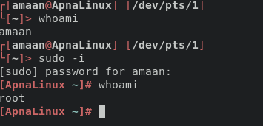

q2) create a new directory names lab1

q3) change directories into lab1

q4) list all files, even hidden files

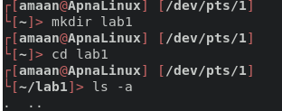

q5) create a new file that contains the calendar for this month

q6) list all files again

q7) display entire contents of the new file

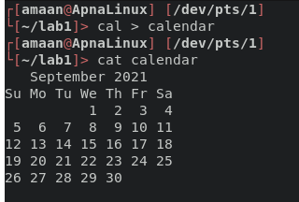

q8) delete the file

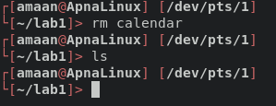

q9) ask the system when is easter in 2021

q10) ask the system for today’s date

